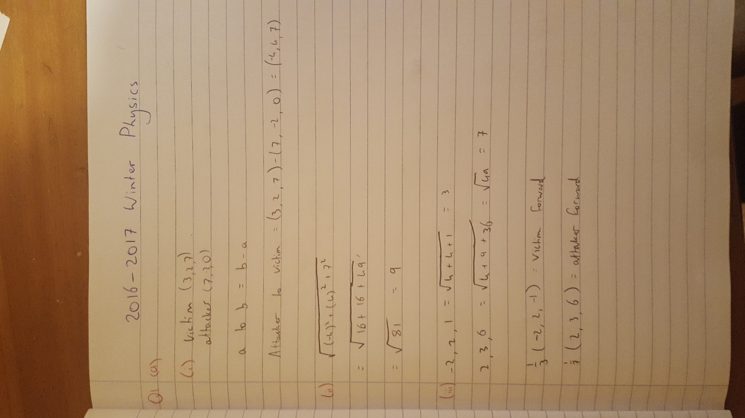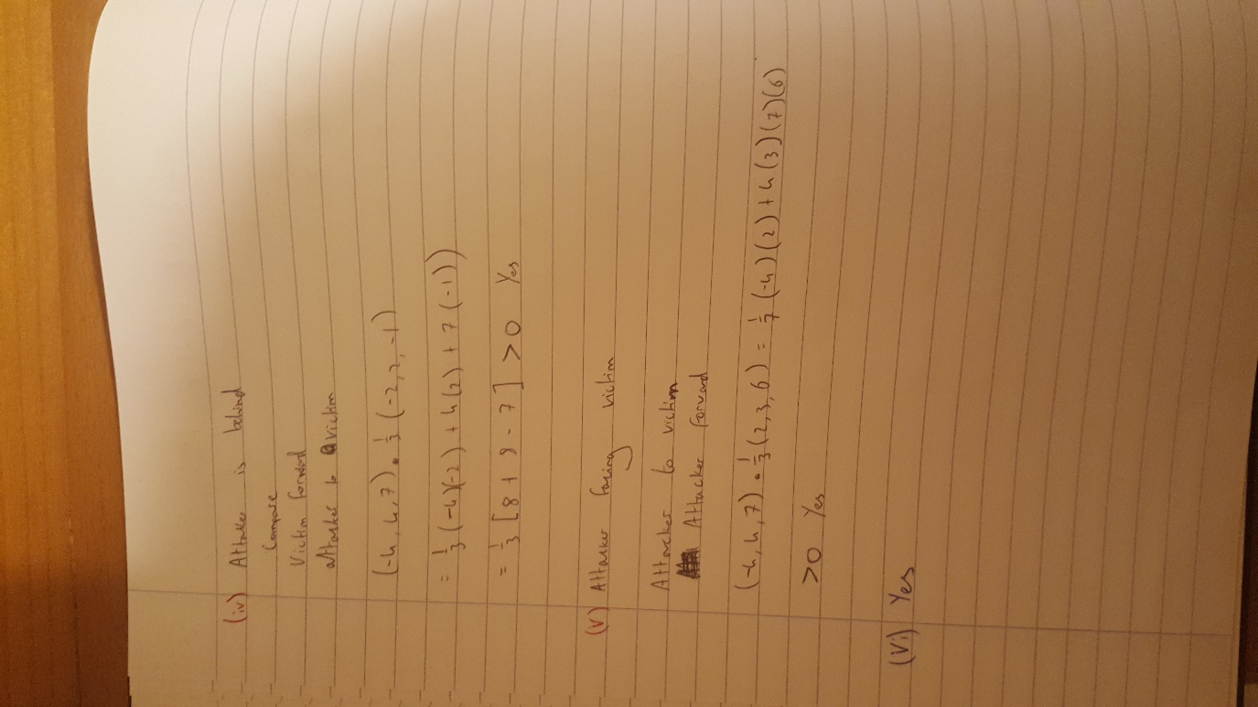

(B) (i) Framerate dependent games are games that run at the same speed, no matter the framerate. For example, a game might run at 30FPS on a slow computer, and 60FPS on a fast one. A framerate independent game progresses at the same speed on both computers.

(ii) while(!done){

//update all objects;

Foreach(object in objects){

object.position += object.velocity;

}

//rendering…..etc….

}

(iii)

Work formula

W = Fd cosθ

Reference:- <https://unity3d.com/learn/tutorials/topics/physics/adding-physics-forces>